Data Driven Recommendation fior Foodie’s Expansion

(DOM 207/636)

VEER KUKRETI

Introduction

Foodie's, a restaurant, is considering business expansion. To make informed decisions, they need to understand the key factors influencing customer spending and tipping behavior based on their existing transaction data.
The primary objective of this study is to leverage the provided transaction data to identify actionable insights and suggest practical business expansion strategies for Foodie’s management. This will be achieved by characterizing transactional and demographic variables, studying relationships between continuous variables, and comparing customer behavior across categorical groups.

Data Pre -Processing Strategy

Problems encountered | Data Cleaning Strategy
Missing values in numerical data | Nearest neighbor mean approach was used to fill in the numerical data if blanks cells were found
Missing values in categorical data | The mode of that specific type of cell was used (eg: if the cell contained a missing value adn the day was much and day thursday, the fields were filtered according to these fields and the mode for the missing value was found)
Typos in numerical data | Typos were fixed after referencing similar cells which contained the same data under the specific field. Eg if a cell in the the amount col contained a value where “,” was used instead of decimals, we fixed it according to our understanding
Typos | MOde was used to filter out the field where the typos were made and the cell was filled according to the mode of that certain row data

Data Cleaning Explained:

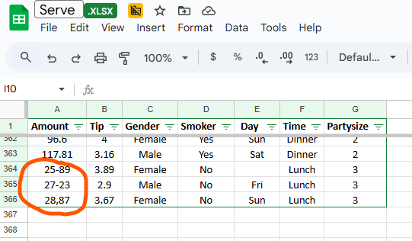
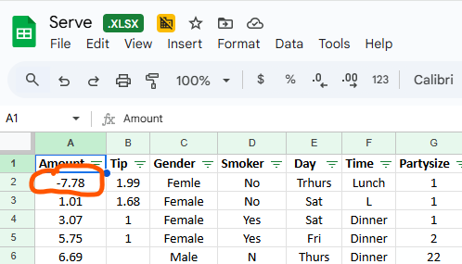
- Typos in numerical data: As the amount cannot be negative , we considered this to be a typo , other examples are , a “,” instead of decimal and same can be said for 27-23, similar cells based on the respective fields were referred to correct the typos.

- Categorical typo: these typos were often very easy to fill in , but osme typos were differently handled as seen in the first photo. For such typos the mode was taken looking at the typo cell’s fields . Therefore, to finalize the value of the”S” in the first photo, we narrowed down the Time column to the value ofLunch and the smoker column to the value of “Yes”. After filtering , we took out the mode of the day col and based on the mode the value was filled in.

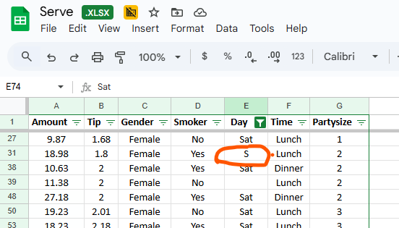
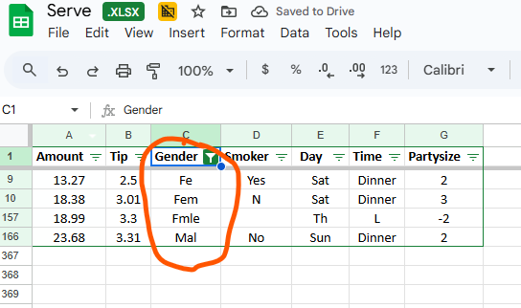

- Multiple Numerical blanks: We addressed these issues by replacing blank by median because the data of both amount and tip was found to be highly skewed.
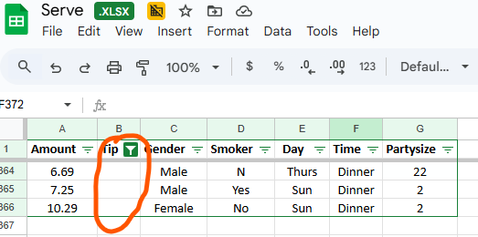

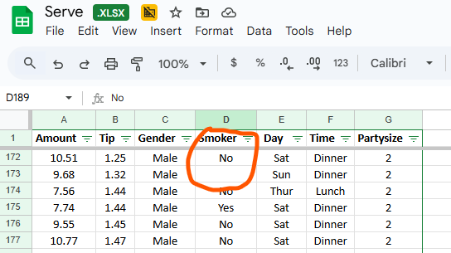
- Missing categorical values: For missing values the mode was taken looking at the typo cell’s fields .Therefore, to finalize the value of this smoker blank cell in the photo, we narrowed down the Time column to the value of dinner and the day was filtered to Saturday column , we took out the mode of the blank smoker col and based on the mode the value was filled in. The data preprocessing was done in this manner for every typological error or blanks given.

Data Visualization:
We used descriptive statistics methods to visualize the data and get a sense of data characteristics. We used python to draw histograms and box plots wherever necessary. The histogram of the Amount and Tip variable shows that the data is not normally distributed. Therefore we decided to use the log transformation for these variables to ensure that any testing that was going to be done would yield highly skewed results.

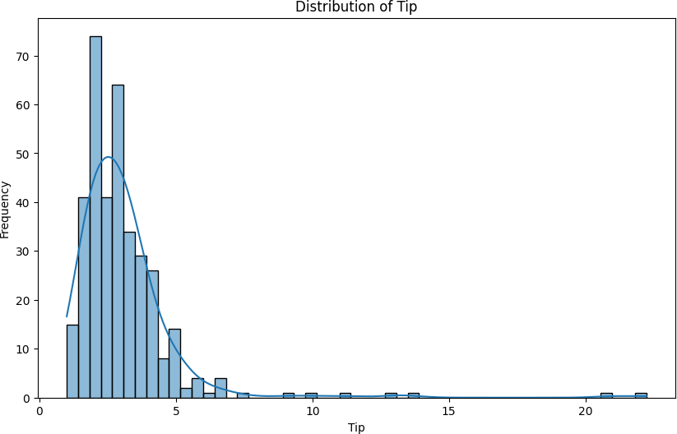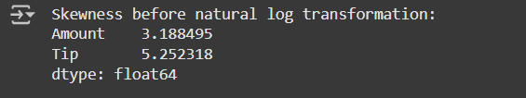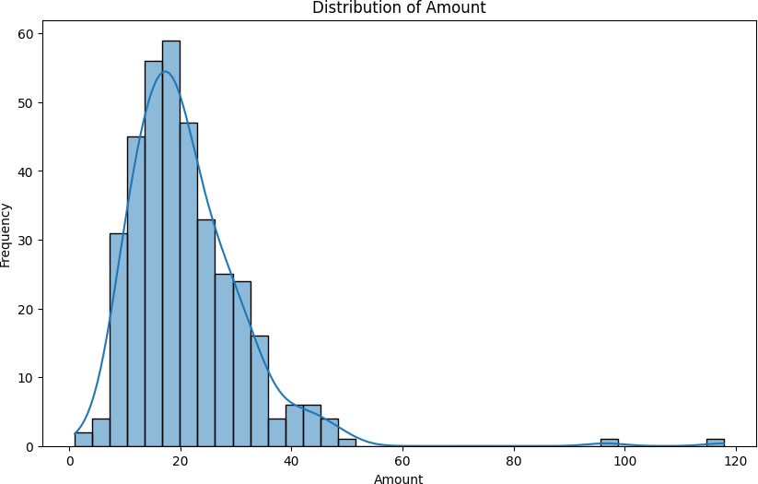
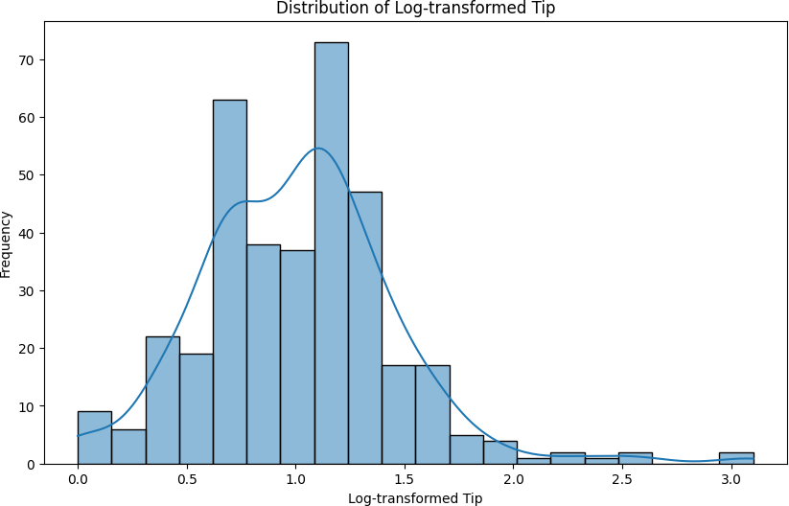
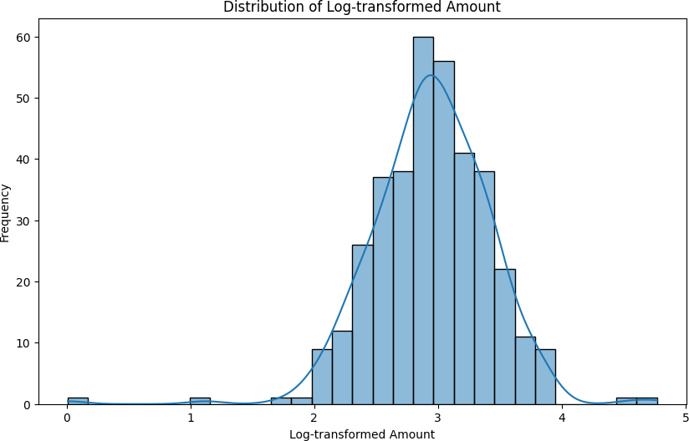
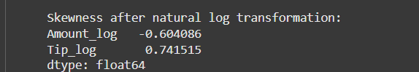

We also discovered interesting patterns of revenue data and tips data across day and customer types. Figure 1 clearly illustrates that weekends are the primary revenue engine for Foodie India. The median total bill amount on Saturday and Sunday is substantially higher than on the preceding weekdays. This visual confirms that weekends represent the core of the business's financial activity.

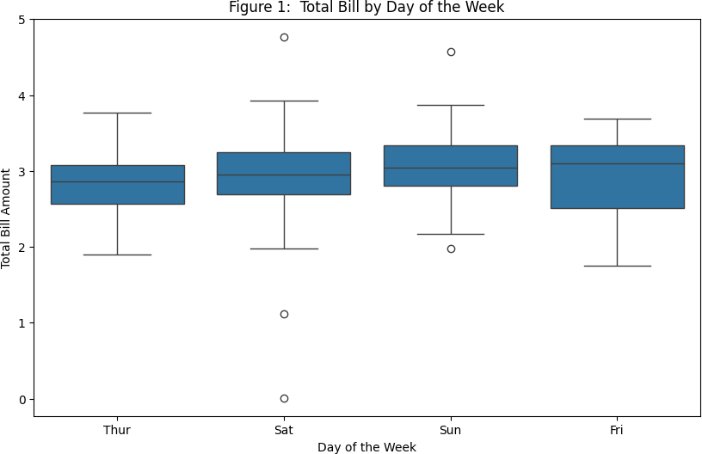

Figure 2 also reveals an interesting finding; it plots the mean tip percentage for smokers and non-smokers across the week. The lines are nearly identical on weekdays, but they decrease on weekends. This is the visual proof indicating that the customer experience for these two groups is inconsistent and breaks down during peak business hours on the weekends.
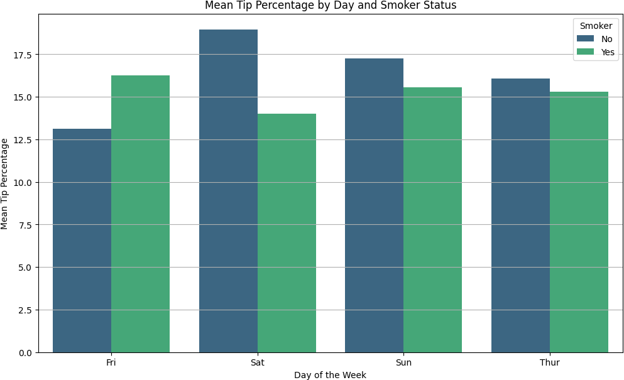

Statistical Testing and Analysis:

While we attempted various combinations of variables to test hypotheses, in this section we are presenting the ones that are key to our findings. An exhibit of all the hypothesis test has also been included in the report in the appendix section ( refer: appendix 1)
H₀: There is no difference in mean log_Amount across the days of the week.

H₁: There is a difference in mean log_Amount across at least one day.

Finding 1: Our formal analysis was structured to move from broad revenue patterns to a deep, specific understanding of the customer experience. Every finding presented below is supported by a formal hypothesis test with a significance level of = 0.05.
During our initial part of the analysis we tried to discover; what drives the bottom line? We found that revenue is primarily driven by the day of the week:
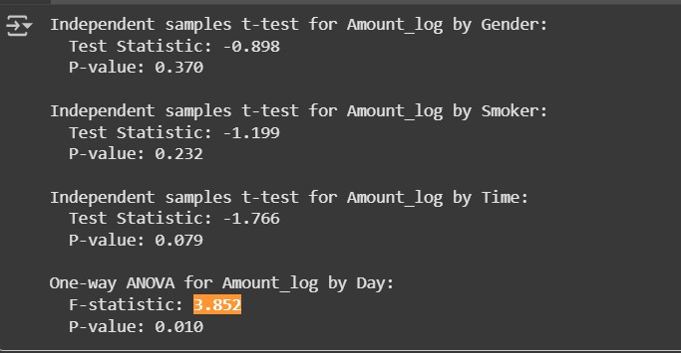
A One-Way ANOVA was conducted to compare the mean log_Amount across all four days. The result was statistically significant (F = 3.852, p = 0.010), proving that revenue is not the same each day. Based on the test done we rejected the null hypothesis to say that revenue varies across days.

H₀: The mean log_Amount is the same for weekends and weekdays.

H₁: The mean log_Amount differs between weekends and weekdays.

Finding 2: A follow-up t-test confirmed that revenue on weekends is significantly higher than on weekdays (p = 0.006). Based on the test done we rejected the null hypothesis to say that

there are higher revenue on weekends.
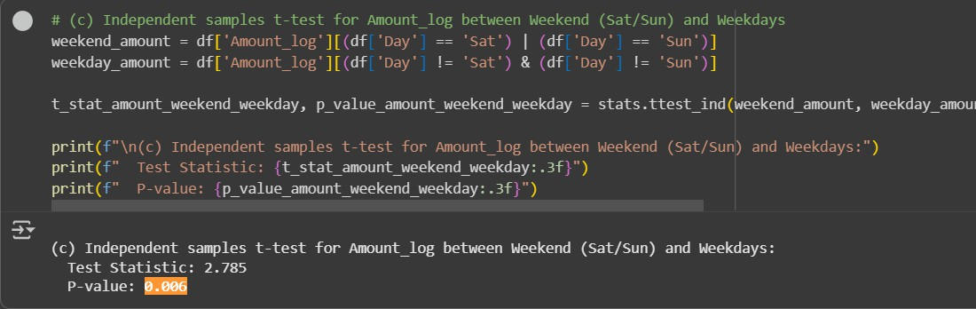

H₀: The mean log_Tip_Percentage is equal on weekends and weekdays.

H₁: The mean log_Tip_Percentage differs between weekends and weekdays.

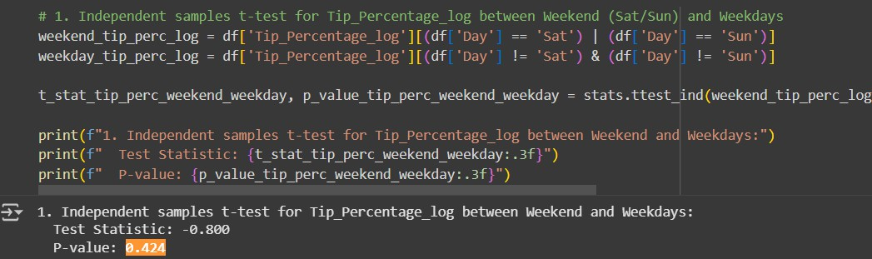
Finding 3: While revenue is higher on weekends, we tested the hypothesis that customer generosity also increases. An Independent Samples T-test was conducted to compare the mean log_Tip_Percentage between weekends and weekdays. The result was not statistically significant (p = 0.424). According to this finding, higher weekend tips are a function of higher bills, not a change in customer generosity. This insight shapes our recommendation to focus on increasing the average bill size. Based on the test done we fail to reject the null hypothesis to say that customer satisfaction is consistent.

H₀: There is no interaction effect between Day and Smoker status on log_Tip_Percentage.
H₁: There is an interaction effect between Day and Smoker status on log_Tip_Percentage.

Finding 4: With a belief that tipping is a function of customer satisfaction, we performed a few more tests to find out insights around the tipping behavior. A Two-Way ANOVA was performed to test for an interaction effect between Day and Smoker status on customer generosity (log_Tip_Percentage). The model revealed a statistically significant interaction effect (F = 2.882, p = 0.036). This proves that the relationship between smoker status and tipping behavior changes depending on the day of the week, pointing to a specific operational issue on weekends.Based on the test done we to reject the null hypothesis to say that tipping behavior changes based on both factors

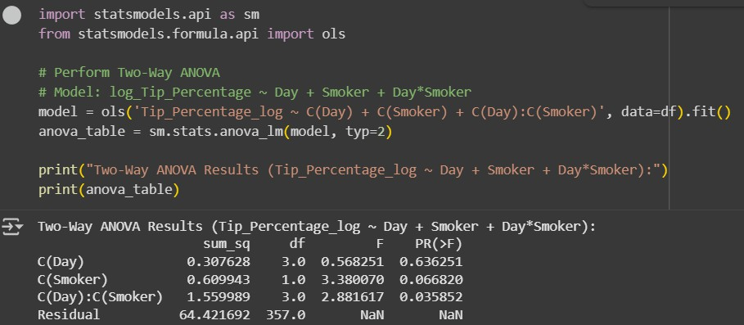

H₀: There is no interaction effect between Day and Smoker status on log_Amount.

H₁: There is an interaction effect between Day and Smoker status on log_Amount.

Finding 5:
- A second Two-Way ANOVA on log_Amount confirmed that this experience gap has a direct financial impact, with a significant interaction effect also found for total revenue (F

= 4.657, p = 0.003). Based on the test done we reject the null hypothesis to say Smoker status affects revenue depending on the day.

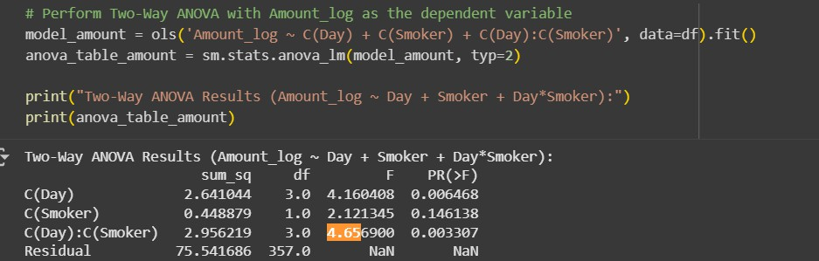

Recommendations:

Our comprehensive analysis of the transaction data suggests that Foodie should follow a two pronged approach for business expansion.
- First, the business must focus on the high-volume peak periods—by strategically increasing the average customer bill.
- Second, and more critically, the business must fix a hidden inconsistency in its customer experience that is currently impacting satisfaction and creating a measurable revenue leak.
The following recommendations provide a specific, data-driven action plan to achieve both objectives.

Recommendation 1: Maximize the Core with a Premium Peak-Period Strategy

This strategy directly targets the restaurant's strongest business period, leverages a proven customer mindset, and focuses on increasing both revenue and total tip dollars.

Our analysis proves that peak periods (weekends) are the primary financial driver of the business. The One-Way ANOVA showed a statistically significant difference in revenue (Amount) across the days of the week (p = 0.010). This tells us that customers visiting during these times are already in a higher-spending mindset. However, our analysis of Tip_Percentage showed that these customers are not inherently more generous; their higher tips are a direct function of their higher bills. The most direct path to expansion, therefore, is to capitalize on this existing behavior.

Action Plan:

  - Pilot a "Peak Performance" premium menu available only during high-traffic dinner and weekend services.
  - This menu should feature higher-margin items.
  - Train staff specifically on upselling these premium items during the busiest shifts.

Recommendation 2: Fix the Experience Gap to Expand Loyalty and Revenue

While a simple analysis shows no overall difference between smokers and non-smokers, our advanced Two-Way ANOVA revealed a statistically significant interaction effect. The difference in both customer generosity (Tip_Percentage, p = 0.036) and total spending (Amount, p = 0.003) between smokers and non-smokers depends entirely on the day of the week.

Action Plan:

  - Launch an immediate "Peak Period Experience Audit" to identify and close the service gap affecting smoker-designated parties.
  - Investigate the root cause: Are these tables in less desirable locations? Is service slower during the rush? Is the ambiance subpar?
  - Enhance the customer environment by creating a dedicated, well-ventilated smoking room or an upscale, comfortable outdoor seating area. Providing a, dedicated space can turn a point of friction into a competitive advantage and a reason for customers to choose your establishment.

Appendix:

Appendix 1: Comprehensive Log of Hypotheses Tested

This section provides a complete summary of all formal hypotheses tested during the analysis, categorized by the final decision. The decisions are based on a significance level (α) of 0.05.

Rejected Null Hypotheses (Statistically Significant Findings)

These findings indicate a real effect or relationship exists. We accept the Alternative Hypothesis (H1).

Business Question | Alternative  Hypothesis (H1) | Test Performed | p-value
Is there a difference in revenue across days? | The mean log_Amount is significantly different on at least one day. | One-Way ANOVA | 0.010
Is there a difference in revenue between weekends & weekdays? | The mean log_Amount for weekends is different from weekdays. | T-test | 0.006
Is there a difference in tips across days? | The mean log_Tip is significantly different on at least one day. | One-Way ANOVA | 0.030

Is there a difference in tips between weekends & weekdays? | The mean log_Tip for weekends is different from weekdays. | T-test | 0.026
Is there a difference in tips between Lunch & Dinner? | The mean log_Tip for Lunch is different from Dinner. | T-test | 0.042
Is there a correlation between Amount & Partysize? | The correlation between log_Amount & Partysize is not zero. | Pearson Correlation | 0.004
On weekends, is generosity different for smokers vs. non-smokers? | The mean log_Tip_Percentage for smokers is different from  non-smokers. | T-test | 0.013
Does the effect of Smoker status on Tip_Percentage depend on the Day? | There is a significant interaction effect between Day and Smoker. | Two-Way ANOVA | 0.036
Does the effect of Smoker status on Amount depend on | There is a significant interaction effect | Two-Way ANOVA | 0.003

the Day? | between Day and Smoker.

Failed to Reject Null Hypotheses (Non-Significant Findings)

These findings indicate that there is not enough statistical evidence to conclude that a real effect or relationship exists. We accept the Null Hypothesis (_˝0).

Business Question | Null Hypothesis (_˝0) | Test Performed | p-value
Is generosity different between weekends & weekdays? | The mean log_Tip_Percentage for weekends equals weekdays. | T-test | 0.424
On weekends, is generosity different between Lunch & Dinner? | The mean log_Tip_Percentage for Lunch equals Dinner. | T-test | 0.264
On weekends, is generosity different by waiter gender? | The mean log_Tip_Percentage for male waiters equals female. | T-test | 0.597
On weekends, is there a correlation between Tip_Percentage & Partysize? | The correlation between log_Tip_Percentage & Partysize is zero. | Pearson Correlation | 0.874

Does revenue differ by waiter gender? | The mean log_Amount for male waiters equals female waiters. | T-test | 0.370
Does revenue differ by smoker status (overall)? | The mean log_Amount for smokers equals non-smokers. | T-test | 0.232
Does revenue differ between Lunch & Dinner? | The mean log_Amount for Lunch equals Dinner. | T-test | 0.079
Do tips differ by waiter gender (overall)? | The mean log_Tip for male waiters equals female. | T-test | 0.408
Do tips differ by smoker status (overall)? | The mean log_Tip for smokers equals non-smokers. | T-test | 0.545

